Chapter 2

Physical Layer

**Physical Layer**

* The lowest layer of the OSI reference model is the physical layer. It is responsible for the actual physical connection between the devices.
* The physical layer contains information in the form of**bits.** It is responsible for transmitting individual bits from one node to the next.
* When receiving data, this layer will get the signal received and convert it into 0s and 1s and send them to the Data Link layer, which will put the frame back together.

The functions of the physical layer are:

* **Bit synchronization:** The physical layer provides the synchronization of the bits by providing a clock. This clock controls both sender and receiver thus providing synchronization at bit level.
* **Bit rate control:** The Physical layer also defines the transmission rate i.e. the number of bits sent per second.
* **Physical topologies:** Physical layer specifies the way in which the different, devices/nodes are arranged in a network i.e. bus, star or mesh topology.
* **Transmission mode:** Physical layer also defines the way in which the data flows between the two connected devices. The various transmission modes possible are: Simplex, half-duplex and full-duplex.

Transmission Media

* Media are what the message is transmitted over. In other words communication channel is also called as medium.
* Different media have different properties and use in different environment.
* The purpose of the Physical layer is transport a raw bit stream from one computer to another.

Classification of Transmission Media

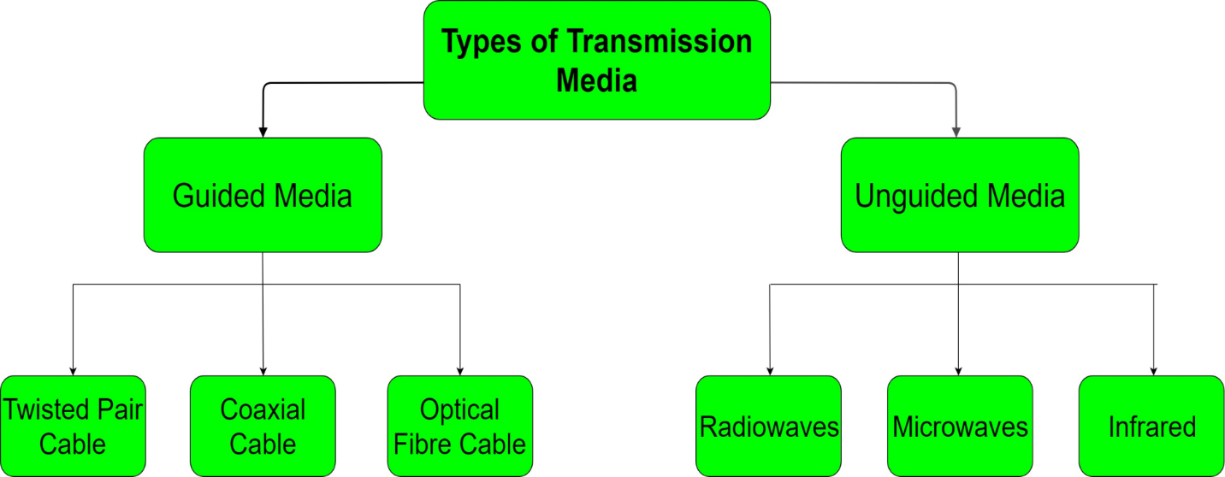

Wired Media

* The signal energy is contained and guided with solid Medium.
* Wired media used for point to point communication.

Types of wired media

* Co-axial cable
* Twisted pair
* Optical Fiber cable

Co-axial Cable

* Coaxial cable is a group of wrapped and insulated wire line.
* They transmit data at higher rates.
* The conductor is made of copper wire surrounded by PVC insulation. This insulation is encased in an outer conductor of metal foil, which is enclosed in a PVC insulation sheath. Also, it is completely covered by a plastic cover.

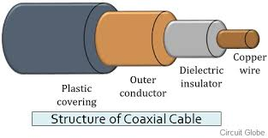

**Advantages of Coaxial Cable**

* Coaxial cable is used in cable television.
* It offers much higher bandwidth.
* It is preferred for long distance telephone lines as well.
* Provides better shield when compared with Twisted Pair cable.
* It offers data transmission without any distortion.
* Expect quite higher noise immunity from coaxial cable.

**Disadvantages of Coaxial Cable**

* Costlier than Twisted pair cable
* BNC connectors are required for connection.

Types of Co-axial Cable

**Baseband Coaxial Cable**

* LAN generally uses Baseband Coaxial cable. It is the 50 ohm coaxial cable used for digital transmission. The cable comes with a power of transmitting a single signal at quite high speed. It transmits a single signal at a time.

**Broadband Coaxial Cable**

* This cable transmits many simultaneous signals and that too using different frequency. It covers more area than the Baseband coaxial cable and can run nearly 100km.

**Applications of Coaxial Cable**

* Analog telephone network
* Cable TV
* Digital telephone network
* Traditional LAN Network

**Twisted Pair cable**

* This is commonly use medium and it is cheaper than co-acial cable.
* It is made up of two insulated copper wires, typically, twisted around each other in a continuous spiral.
* The purpose of twisting the wires is to reduce electrical interference (or noise) from similar pairs close by.

Types of Twisted pair cable.

* Unshielded twisted pair
* Shielded twisted pair

Unshielded twisted pair cable

* UTP is the type of twisted pair cable. It stands for Unshielded twisted pair.
* Both Data and voice both are transmitted through UTP because its frequency range is suitable.
* In UTP grounding cable is not necessary also in UTP much more maintenance are not needed therefore it is cost effective.

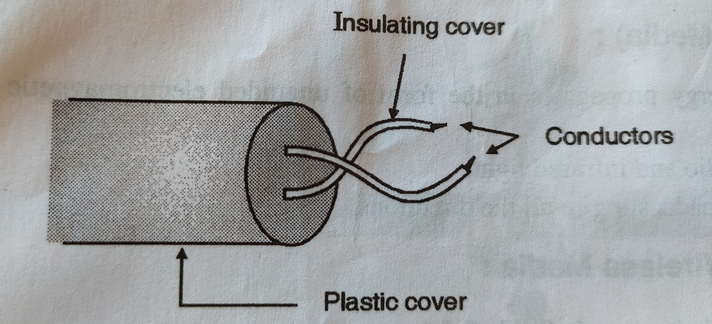

Advantages of Unshielded Twisted Pair Cable

* Installation is easy
* Flexible
* Cheap
* It has high speed capacity,
* 100 meter limit
* Higher grades of UTP are used in LAN technologies like Ethernet.

Disadvantages of Unshielded Twisted Pair Cable

* Bandwidth is low when compared with Coaxial Cable
* Provides less protection from interference.

**Shielded twisted pair cable**

* STP is also the type of twisted pair which stands for Shielded twisted pair. In STP grounding cable is required but in UTP grounding cable is not required.
* In Shielded Twisted Pair (STP) much more maintenance is needed therefore it is costlier than Unshielded Twisted Pair (UTP).

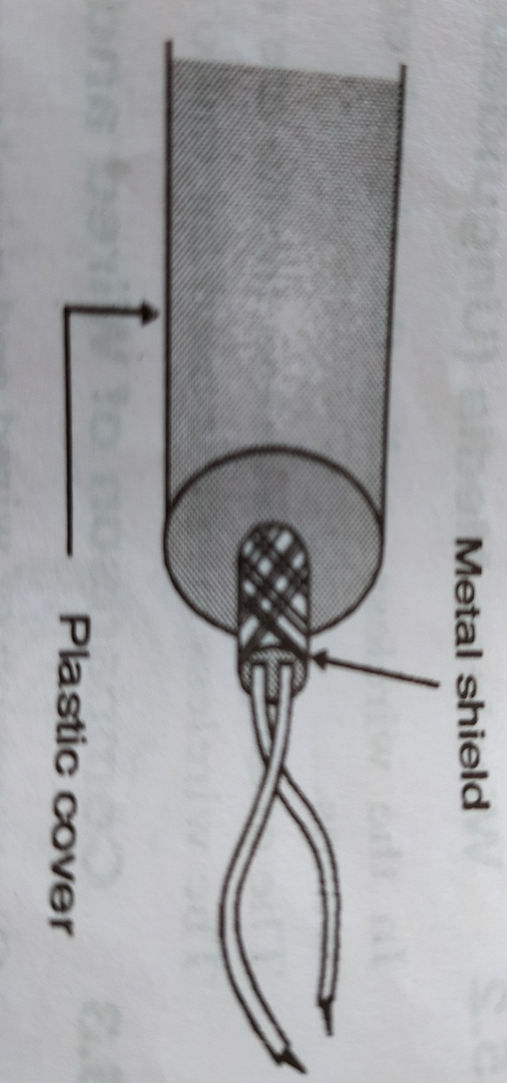

**Advantages of Shielded Twisted Pair Cable**

* Easy to install
* Performance is adequate
* Can be used for Analog or Digital transmission
* Increases the signaling rate
* Higher capacity than unshielded twisted pair
* Eliminates crosstalk

Disadvantages of Shielded Twisted Pair Cable

* Difficult to manufacture
* Heavy
* It is the most expensive wire from UTP cables.
* It requires more maintenance to reduce the loss of data signals.
* There is no segment improvement in length despite its thick and heavier connection.
* It is used only as a grounded wire.

Application of Twisted pair cable

* LAN
* Conventional telephone line

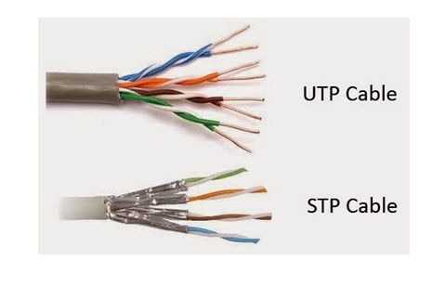

**Optical Fiber cable**

* It consists of an inner glass core surrounded by a glass cladding which has lower refractive index and protective covering.
* Digital signals are transmitted in form of intensity modulated light signals.
* Light is launched into a fiber at end using light source like LED and detected by other side using photo detector.

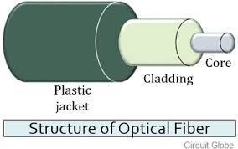

**Principal of propagation**

* The angle of incidence i.e. Ø is greater than the critical angle Øc therefore the incident light ray will be reflated within the core totally.
* If the incident light makes an angle which is less than critical angle Øc then it’s get refracted.

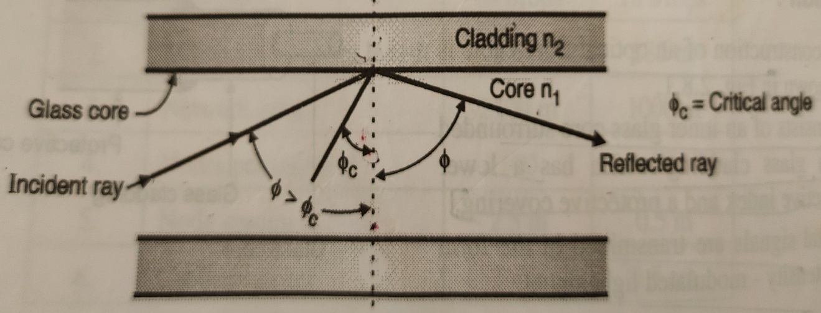

Modes of propagation

* Single Mode
* Multimode

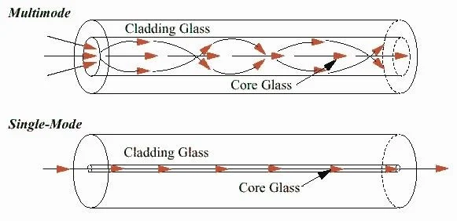

**Advantages of Optical Fiber cable**

* Small size and light weight
* Easy available
* No electromagnetic interference
* Large bandwidth
* No crosstalk

**Disadvantages of Optical Fiber cable**

* Cost is high
* Sophisticated plants are required for manufacturing.
* Joining the cables is difficult job.

Applications of Optical Fiber cable

* LAN
* Telephone Network
* Cable television
* Defense/Government
* Medical